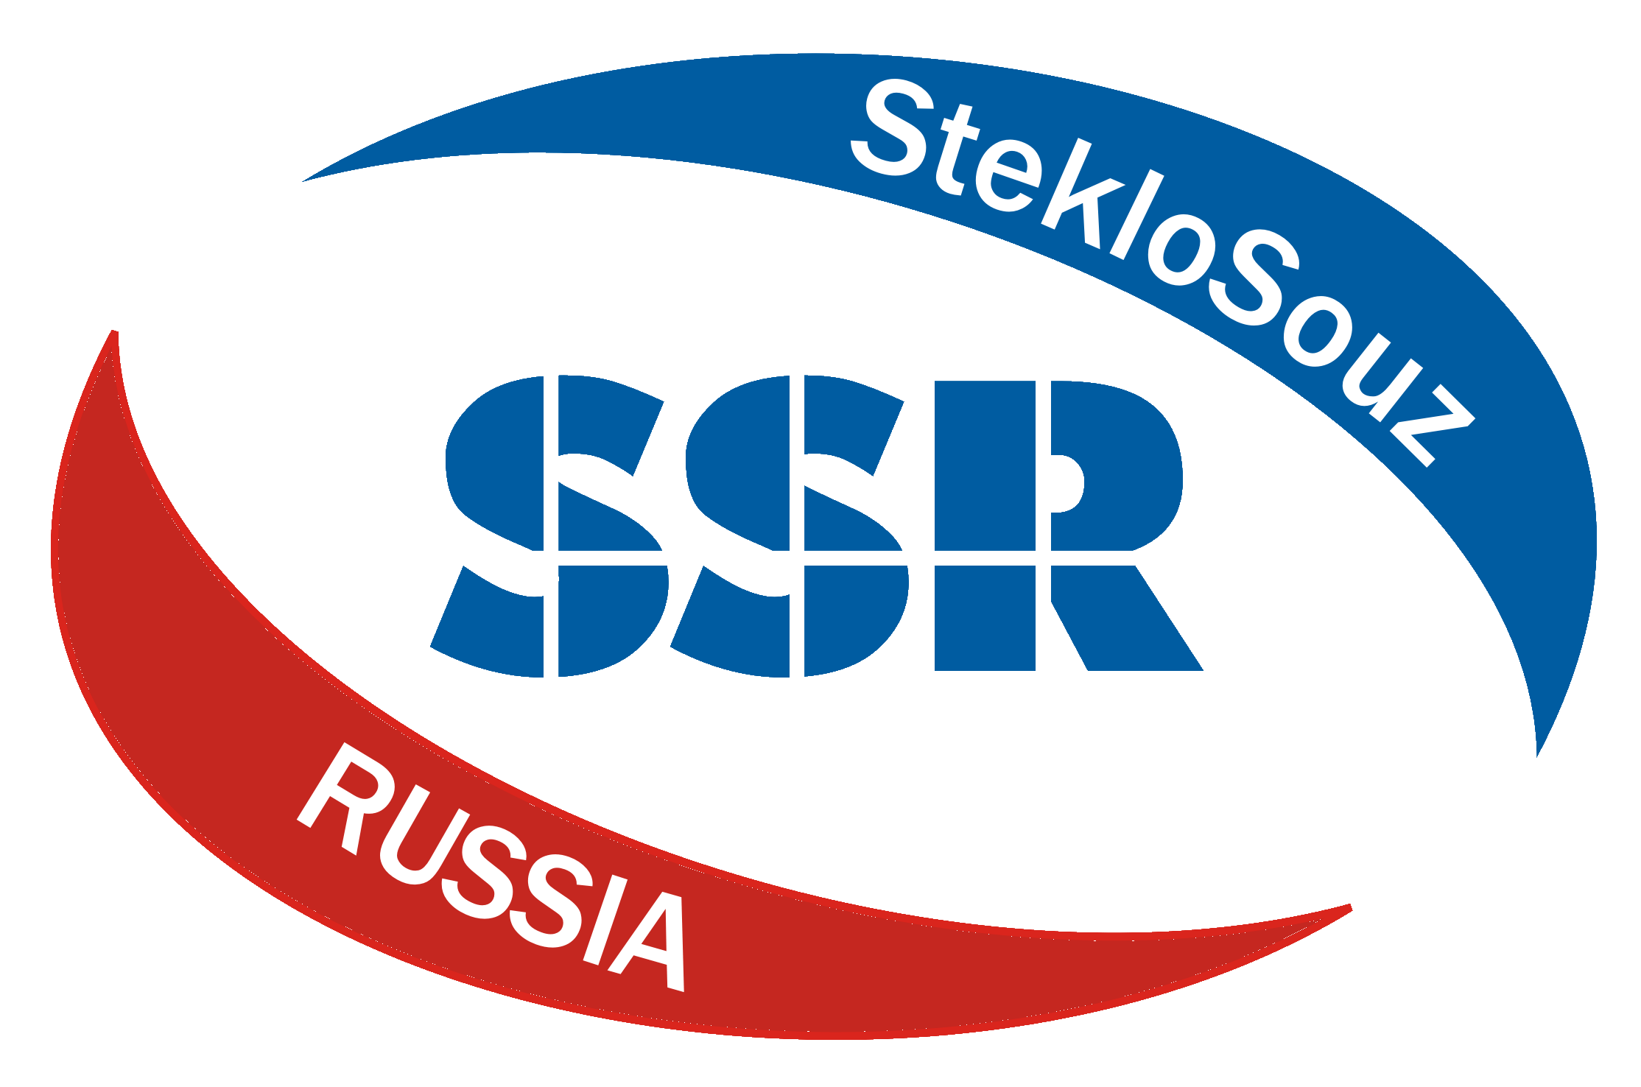
Application for participation in
International Conference
"Glass and modern technologies - XXI".
November 30, 2023
Moscow, Miusskaya Square, 9, Great Assembly Hall
(entrance from 1st Miusskaya Street, 3 / checkpoint).

Please, fill the given demand and direct in "StekloSouz":
e-mail: osipov@steklosouz.ru, admin@steklosouz.ru
Tel.: +7 (495) 777-8200/beep/2639, (2638), +7-916-010-4126
The contact person:______________________________________________________________
The company name: ____________________________________________________________
Post: ___________________________________________________________________
The address: ___________________________________________________________
INN/KPP: ___________________________________________________________________
Tel.: _____________________________________________________________________
Fax: ________________________________________________________________________
E – mail: ______________________________________________________________________

1. I ask to register as a speaker of the conference:
Name, position:
_______________________________________________________________________________
________________________________________________________________________________
2. Theme of my performance (presentation) at conference (eng, rus) : _____________________________________________________________________________________
_______________________________________________________________________________________________________________________________________________ Performance time: 10-15 min.

3. I ask to register as a participant(s) of the conference:
Name of participants, position:
____________________________________________________________________________________
____________________________________________________________________________________
4. I ask to send the contract with the estimate of expenses and an abacus:

Target contribution for the organization of the Conference, including:

The right item in the table should be noted!

№ п/п | Services | Price for an item, (without VAT), euro | Cost  (without VAT), euro | Note
1 | Registration payment. It is paid for each participant | 200
2. | Performance of a scientific report | 200
3 | Presentation of the companies | 300
4 | Placing of an advertising module of the company at industry portal SSR. The term is 3 months. | 600
 | Total (The VAT isn't assessed):

The signature and the press ______________________________________________Date________________

